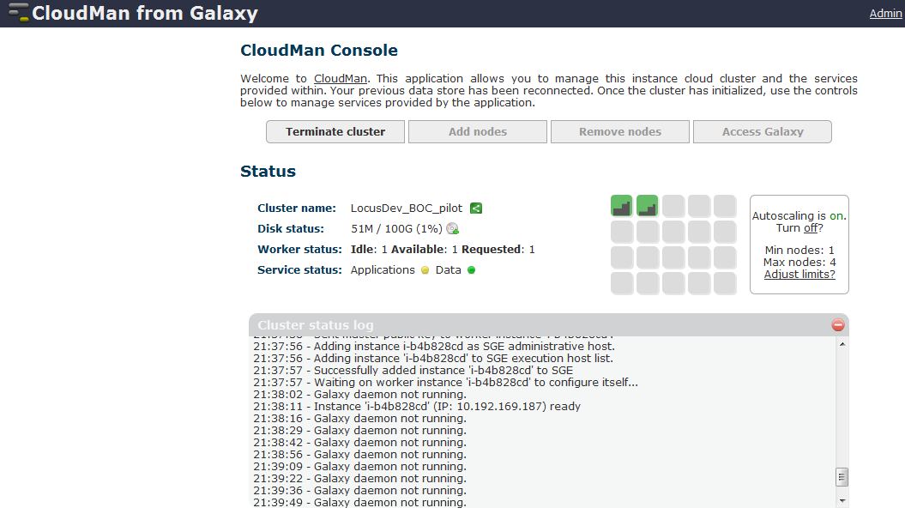

Cluster status log
- 21:29:35 - Retrieved file 'persistent_data.yaml' from bucket 'cm-015742ab945fd2ea568906cde9a3c908' to 'pd.yaml'.
- 21:29:35 - Master starting
- 21:29:36 - Completed initial cluster configuration. Starting previously existing cluster of type Galaxy
- 21:29:40 - SGE prerequisites OK; starting the service
- 21:29:48 - Configuring SGE...
- 21:30:00 - Successfully setup SGE; configuring SGE
- 21:30:15 - Successfully mounted file system /mnt/galaxyIndices from /dev/sdg1
- 21:30:28 - Successfully mounted file system /mnt/galaxyTools from /dev/sdg2
- 21:30:39 - Successfully mounted file system /mnt/galaxyData from /dev/sdg3
- 21:30:40 - Postgres prerequisites OK; starting the service
- 21:30:40 - PostgreSQL daemon NOT running.
- 21:30:40 - PostgreSQL daemon NOT running.
- 21:30:40 - Starting PostgreSQL...
- 21:30:42 - Successfully started PostgreSQL.
- 21:30:42 - Galaxy prerequisites OK; starting the service
- 21:30:43 - Setting up Galaxy application
- 21:30:44 - Retrieved file 'universe_wsgi.ini.cloud' from bucket 'cloudman' to '/mnt/galaxyTools/galaxy-central/universe_wsgi.ini'.
- 21:30:45 - Retrieved file 'tool_conf.xml.cloud' from bucket 'cloudman' to '/mnt/galaxyTools/galaxy-central/tool_conf.xml'.
- 21:30:45 - Retrieved file 'tool_data_table_conf.xml.cloud' from bucket 'cloudman' to '/mnt/galaxyTools/galaxy-central/tool_data_table_conf.xml.cloud'.
- 21:30:45 - Starting Galaxy...
- 21:30:58 - Saved file 'persistent_data.yaml' to bucket 'cm-015742ab945fd2ea568906cde9a3c908'
- 21:31:55 - Galaxy daemon not running.
- 21:31:55 - Galaxy service state changed from 'Starting' to 'Error'
- 21:31:55 - Saved file 'persistent_data.yaml' to bucket 'cm-015742ab945fd2ea568906cde9a3c908'
- 21:32:08 - Galaxy daemon not running.
- 21:32:21 - Galaxy daemon not running.
- 21:32:34 - Galaxy daemon not running.
- 21:32:47 - Galaxy daemon not running.
- 21:33:00 - Galaxy daemon not running.
- 21:33:14 - Galaxy daemon not running.
- 21:33:26 - Galaxy daemon not running.
- 21:33:39 - Galaxy daemon not running.
- 21:33:53 - Galaxy daemon not running.
- 21:34:05 - Galaxy daemon not running.
- 21:34:18 - Galaxy daemon not running.
- 21:34:31 - Galaxy daemon not running.
- 21:34:44 - Galaxy daemon not running.
- 21:34:57 - Galaxy daemon not running.
- 21:35:10 - Galaxy daemon not running.
- 21:35:23 - Galaxy daemon not running.
- 21:35:23 - Adding 1 on-demand instance(s)
- 21:35:27 - Cannot get cloud instance object without an instance ID?
- 21:35:27 - AS prerequisites OK; starting the service
- 21:35:27 - Saved file 'persistent_data.yaml' to bucket 'cm-015742ab945fd2ea568906cde9a3c908'
- 21:35:36 - Galaxy daemon not running.
- 21:35:37 - Cannot get cloud instance object without an instance ID?
- 21:35:50 - Galaxy daemon not running.
- 21:35:50 - Cannot get cloud instance object without an instance ID?
- 21:36:03 - Galaxy daemon not running.
- 21:36:04 - Cannot get cloud instance object without an instance ID?
- 21:36:17 - Galaxy daemon not running.
- 21:36:30 - Galaxy daemon not running.
- 21:36:44 - Galaxy daemon not running.
- 21:36:57 - Galaxy daemon not running.
- 21:37:11 - Galaxy daemon not running.
- 21:37:24 - Galaxy daemon not running.
- 21:37:37 - Galaxy daemon not running.
- 21:37:38 - Instance 'i-b4b828cd' reported alive
- 21:37:38 - Successfully generated root user's public key.
- 21:37:38 - Sent master public key to worker instance 'i-b4b828cd'.
- 21:37:56 - Adding instance i-b4b828cd as SGE administrative host.
- 21:37:56 - Adding instance 'i-b4b828cd' to SGE execution host list.
- 21:37:57 - Successfully added instance 'i-b4b828cd' to SGE
- 21:37:57 - Waiting on worker instance 'i-b4b828cd' to configure itself...
- 21:38:02 - Galaxy daemon not running.
- 21:38:11 - Instance 'i-b4b828cd' (IP: 10.192.169.187) ready
- 21:38:16 - Galaxy daemon not running.
- 21:38:29 - Galaxy daemon not running.
- 21:38:42 - Galaxy daemon not running.
- 21:38:56 - Galaxy daemon not running.
- 21:39:09 - Galaxy daemon not running.
- 21:39:22 - Galaxy daemon not running.
- 21:39:36 - Galaxy daemon not running.

